Bikash Kumar Yadav

Sidpriyadarshi01@gmail.com

WEB development Report

Web assign-1

Table of Contents:

Topics Pages

Contents…………………………………………………………………..1

Introduction……………………………………………………………….2

Design……………………………………………………………………..3

-This is my homepage wireframe……………………………………….2

-This is my biography wireframe………………………………….…….3

- This is my curriculum vitae wireframe………………………………...4

- This is my contact wireframe…………………………………………...5

Sketch of my Webpages:

-Sketch 1: This is my homepage sketch………………………………..6

-Sketch 2: This is my biography sketch………….……………………..7

-Sketch 3: This is my curriculum vitae sketch……………………….....8

-Sketch 4: This is my contact sketch……….…………………………...9

Comparable system of personal webpage…………………………….10

-Homepage……………………………………………………………….11

-pros and cons……………………………………………………………12

-contact page……………………………………………………………..13

My Complete website……………………………………………………13

Final webpages design progress (week-12)

-My homepage……………………………………………………………14

-My biography…………………………………………………………….15

-My curriculum vitae………………………………………..……………16

-My contact……………………………………………………………….16

Conclusion………………………………………………………………..17

References………………………………………………..……..18

Introduction:

This is my personal webpage report designed by me. In the beginning of the report i.e. when I started my assignment of the web development, I was very confused about the design of the web pages and also as being a beginner in design field, I get scared when I used to think about the design. So I visit a lots of website on the internet to choose the design but I never get satisfied with any design. But after long research, finally I get some idea about my webpage design.

Design 1:

This is my home page wireframe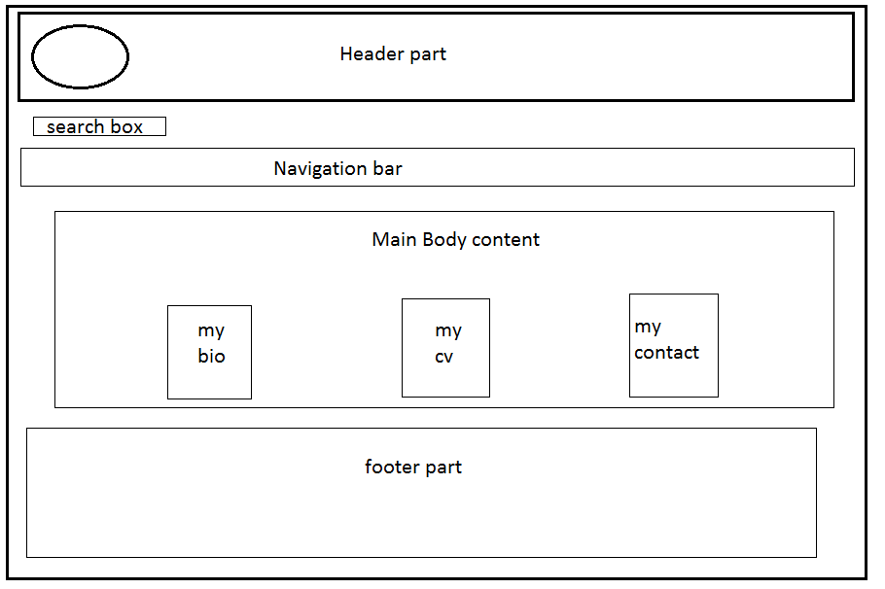

This is my design of home page. The whole page has been divided into four section. The first section is of header section which consist of logo and Title of the webpage. The second section consist of Navigation bar from where we can redirect to other pages easily. The third section consist of body content in which there is three sub section i.e my bio, my cv, my contact. Which makes homepage more attractive and the last section is footer which consist of social media links.

Design:2

This is my biography wireframe

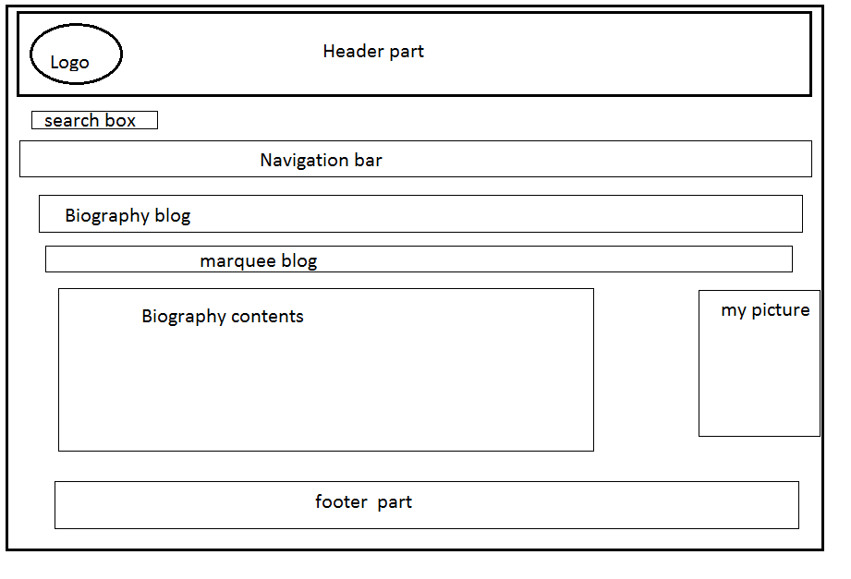

This is my second design of the biography page. In this page the header and footer remains the same. In this page the main section contains one extra section in which there is one marquee blog which contains biography blogs. The second content of the body contains my biography details along with my picture on the left side of the body.

Design:3

This is my curriculum vitae wireframe

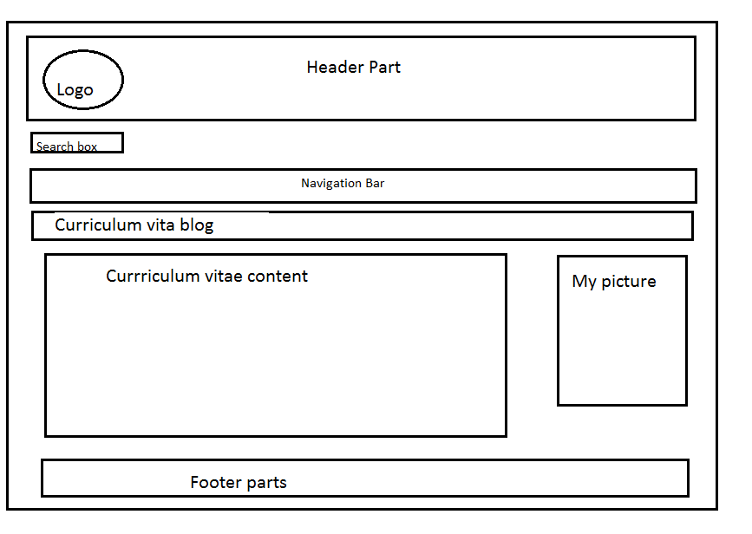

This is third wireframe design of the curriculum vitae webpage. In this page also ,the header and footer parts remains the same. But the difference in this webpage is that the body section contains details about my cv. Besides that it also contains my picture also which also describe the page as pure cv page.

Design: 4

This is my wireframe of contact page

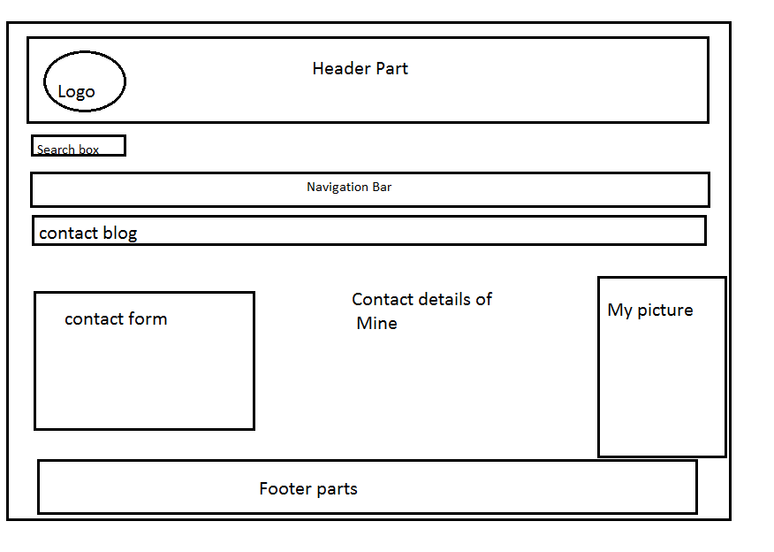

This is my fourth and last wireframe design of my contact page. As we all know that the header and footer remains the same in most of the webpages. So in this webpage also the header and footer contains remains the same. The difference is that body section has been divided into three part, first part contains a contact form from where the user can contact me by signing the given form the second section is about my personal details and the last section contains my own picture.

Sketch of my webpage:

Sketch :1 This is my Homepage Sketch.

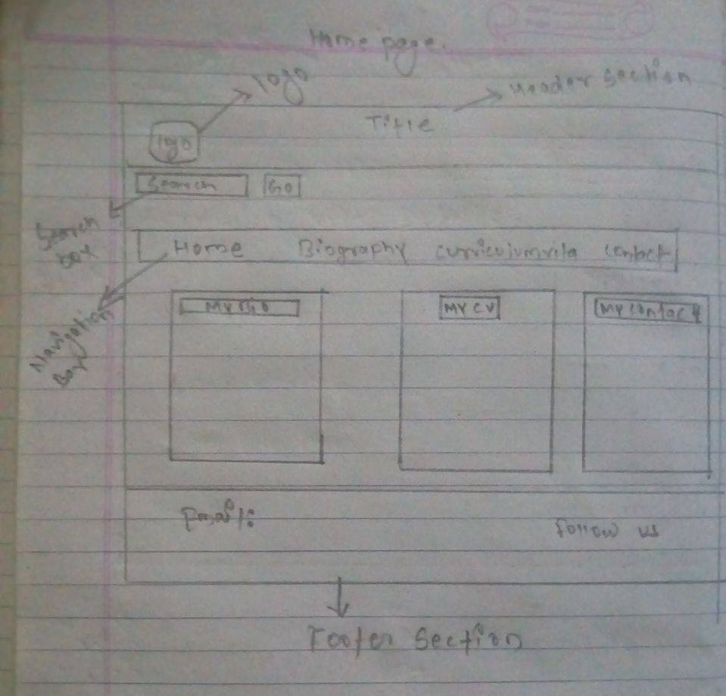

This is my homepage rough sketch which is the blueprint of my original homepage. The homepage contains search box which guides user easily to access any part of the website. Homepage also contains informative navigation bar which is more user friendly for the user.

Sketch :2

This is my Biography sketch.

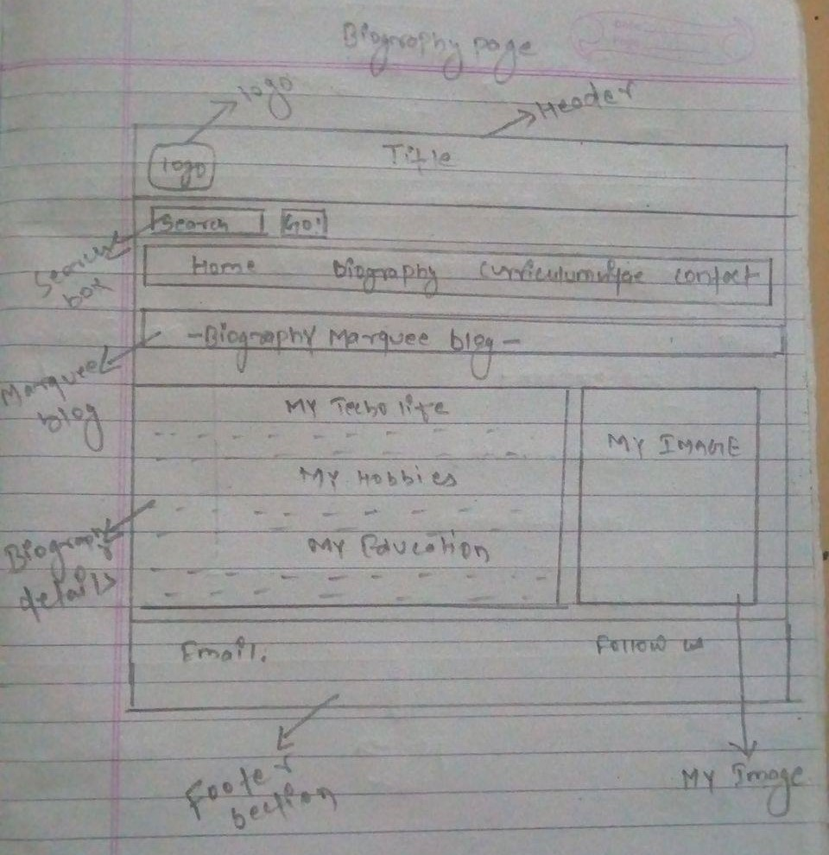

This is my Biography page rough sketch as shown in the figure. The page contains very attractive and eye catching color in the original version of this page. The biography page has got a pink background except the footer parts which makes the page look attractive.

Sketch : 3

This is my third rough sketch i.e Curriculum vitae detail.

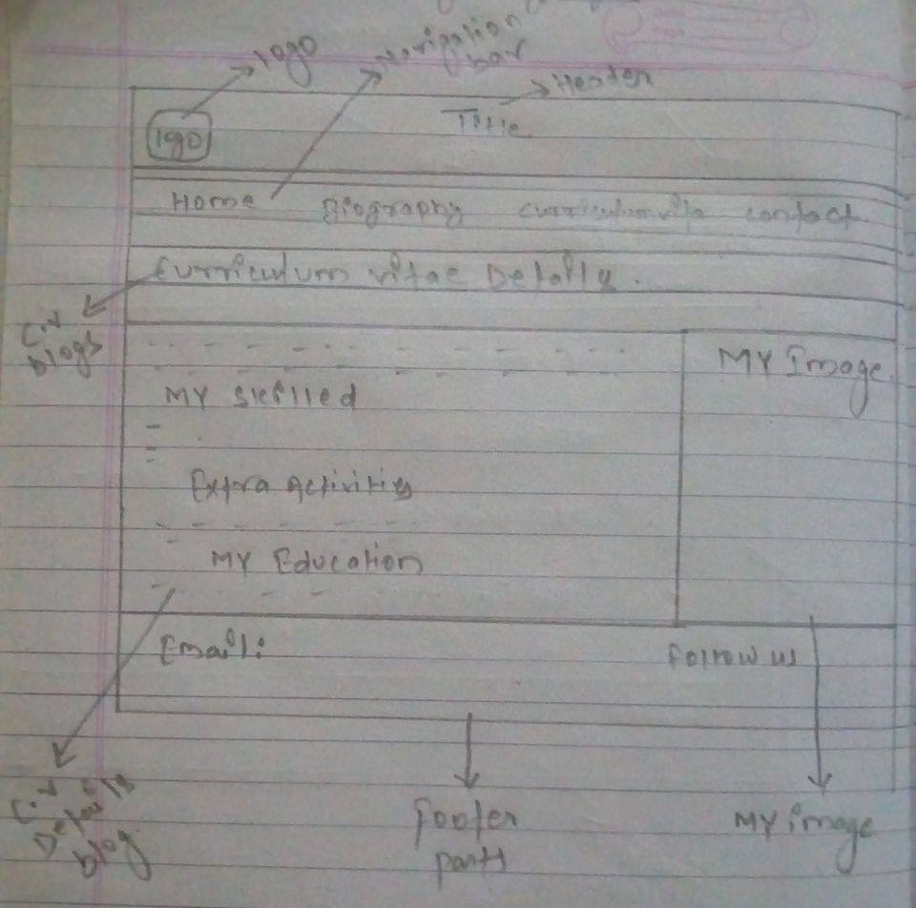

This is my rough sketch of curriculum vitae page. In this page you can find full detail about mine. The page contain details about my skills, my education and Extra skills. Besides that it contain my personal image in the opposite section of my CV details. The background of CV details contain pink color which makes the page attractive.

Sketch: 4

This is my last rough sketch of contact page.

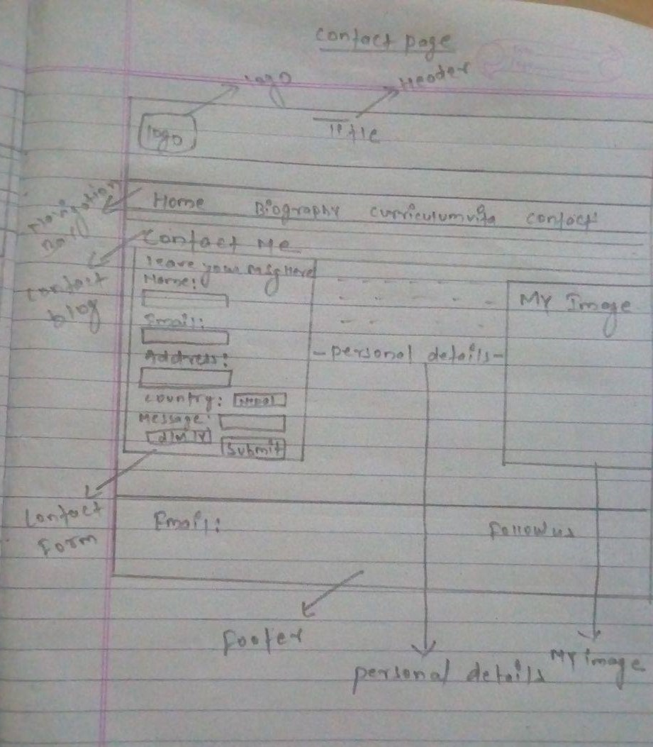

This is the rough sketch of my contact page. In this webpage the body section contains a sign up form in the right side of the page which helps user to contact me by signing up the form along with their details. In the middle section it contains my personal details like address, phone number and Facebook id. Besides that at very left side of the body section it contains my personal image as it is also in other pages .like biography, CV.

Comparable system of personal webpages:

The comparable system of personal webpages is system in which the different other personal webpages are compared for their color combination, usability, font size etc. The pros and cons of that very website are mentioned. During my webpage development phase, I have gone through different personal webpages and compared them. So these are the webpages whose pros and cons part are listed below.

* <https://www.mymoney.gov/Pages/default.aspx>
* Home page

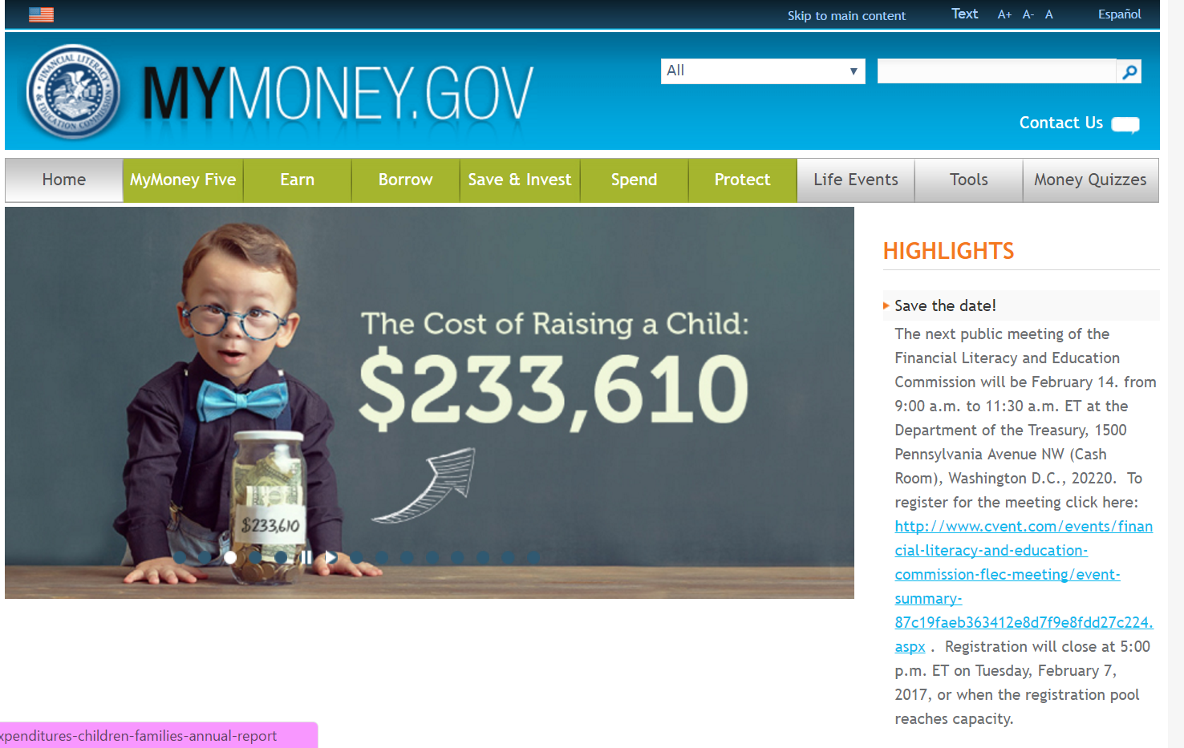

The pros and cons of this Home webpage are listed below.

|  |  |
| --- | --- |
| Positive impact | Negative impact |
| * Color combination look good. | * Sidebar blog looks awkward due to the congested space. |
| * Font size and style looks like professional. | * Presence of more link in sidebar makes it ugly. |
| * Navigation bar looks user friendly. | * Language choose option does not looks good. |

* Contact page

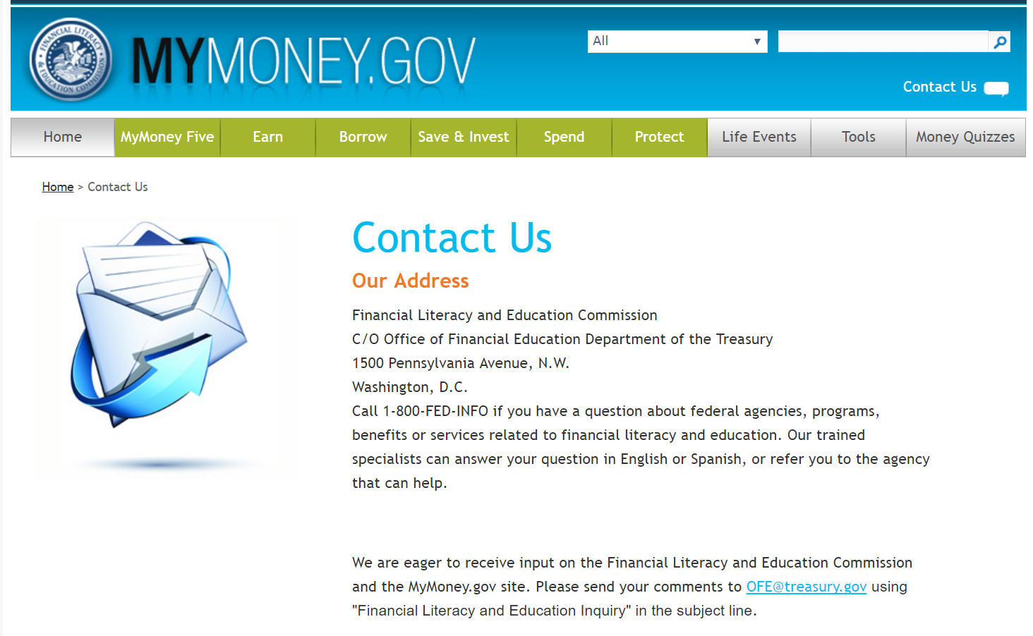

The pros and cons of this contact page of this website are listed below.

|  |  |
| --- | --- |
| Positive impact | Negative impact |
| * Contact details looks more sufficient. | * Contact form is missing in the page. |
| * Background color looks nice. | * Paragraph arrangement has not been like professional. |
| * Font combination has been good. | * Important links are missed in the contact. |

Hence these are the some of the pros and cons of the above mentioned websites webpages, which have been listed above.

My complete website:

* Description

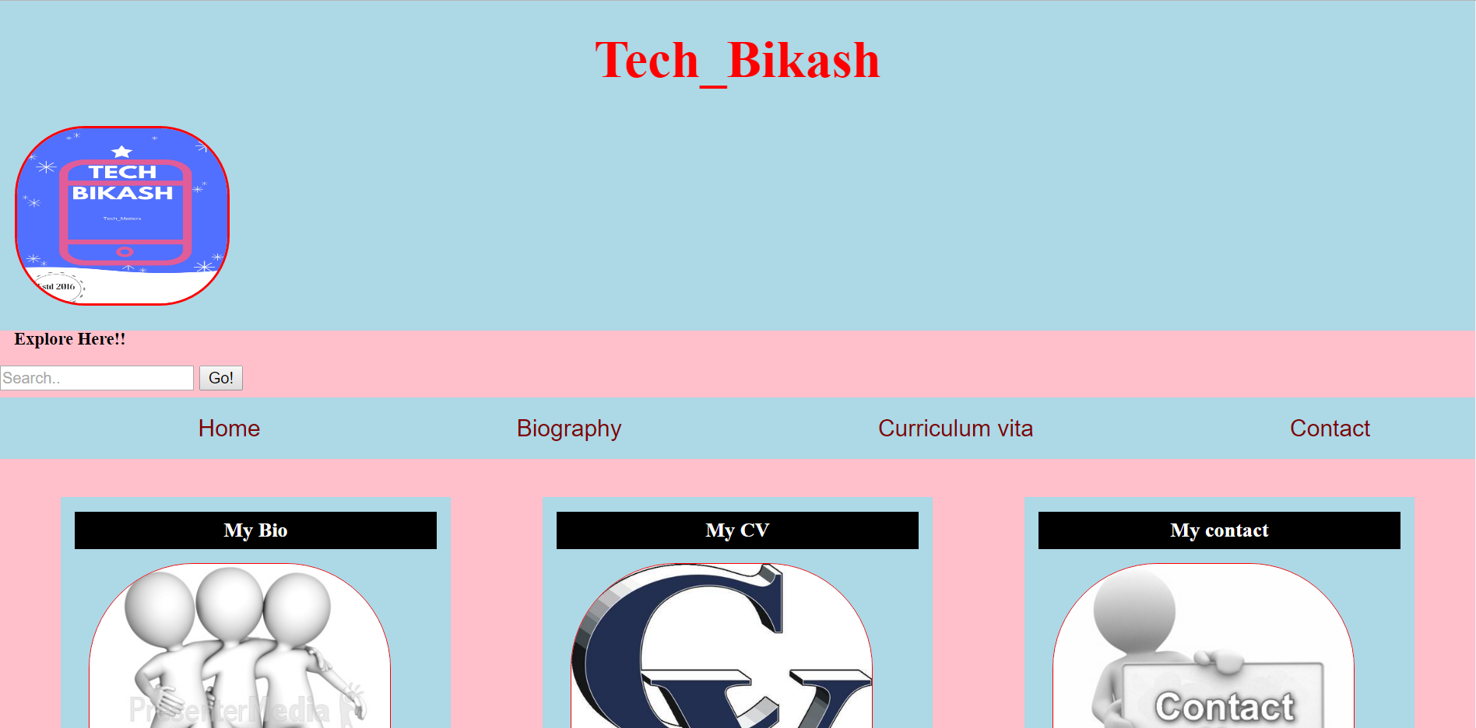

* Header: The header parts of this website consist the title of the webpage along with the logo having background color of sky-blue. The title of the webpage has got red font combination and the logo has also got very thin red border with edgeless corner.
* Navigation bar: The navigation bar of this webpage consist of four menu i.e. Home, Biography, curriculum vitae and contact, which guide user to navigate them to other pages easily.
* Body content: The body section contain three sub section i.e. my bio, my CV and my contact section along with image related to the topic. In the each sub section, I have given link to them because the link redirect them to the related pages. The whole body section contains background of pink and light blue along with black header.
* Footer: The footer parts has been created in a separate div. The footer consist of black background with white fonts. In the left corner of this div it contains social media icon like Facebook, YouTube and twitter. But the link has not provided to them. On the right corner of this div, it contain my copyright details and my email address.

Final webpages Design Progress (week-12):

* My Homepage:

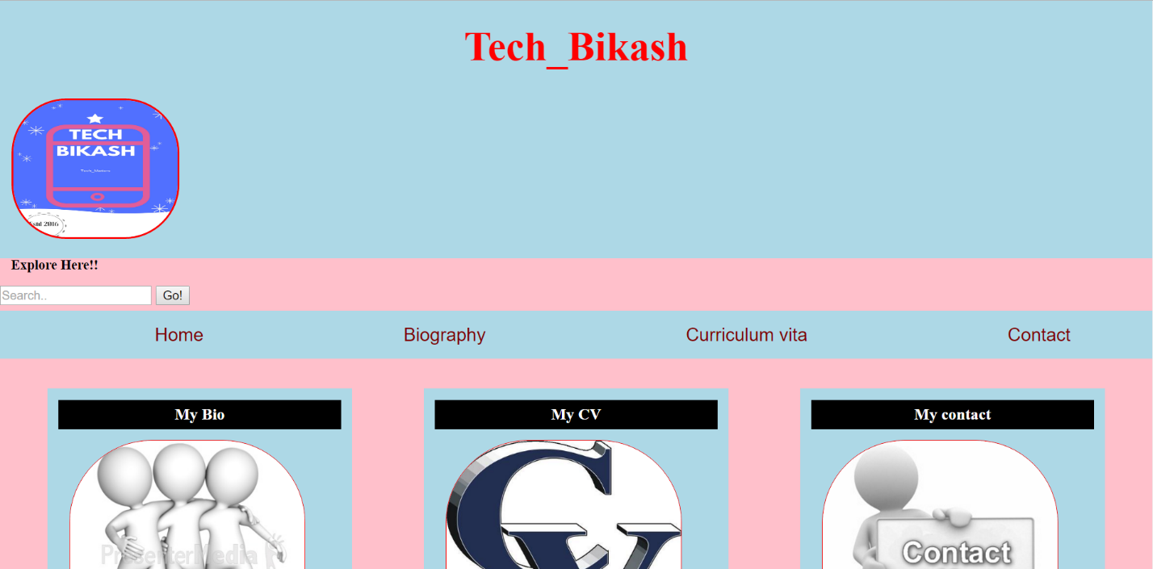

* My Biography page:

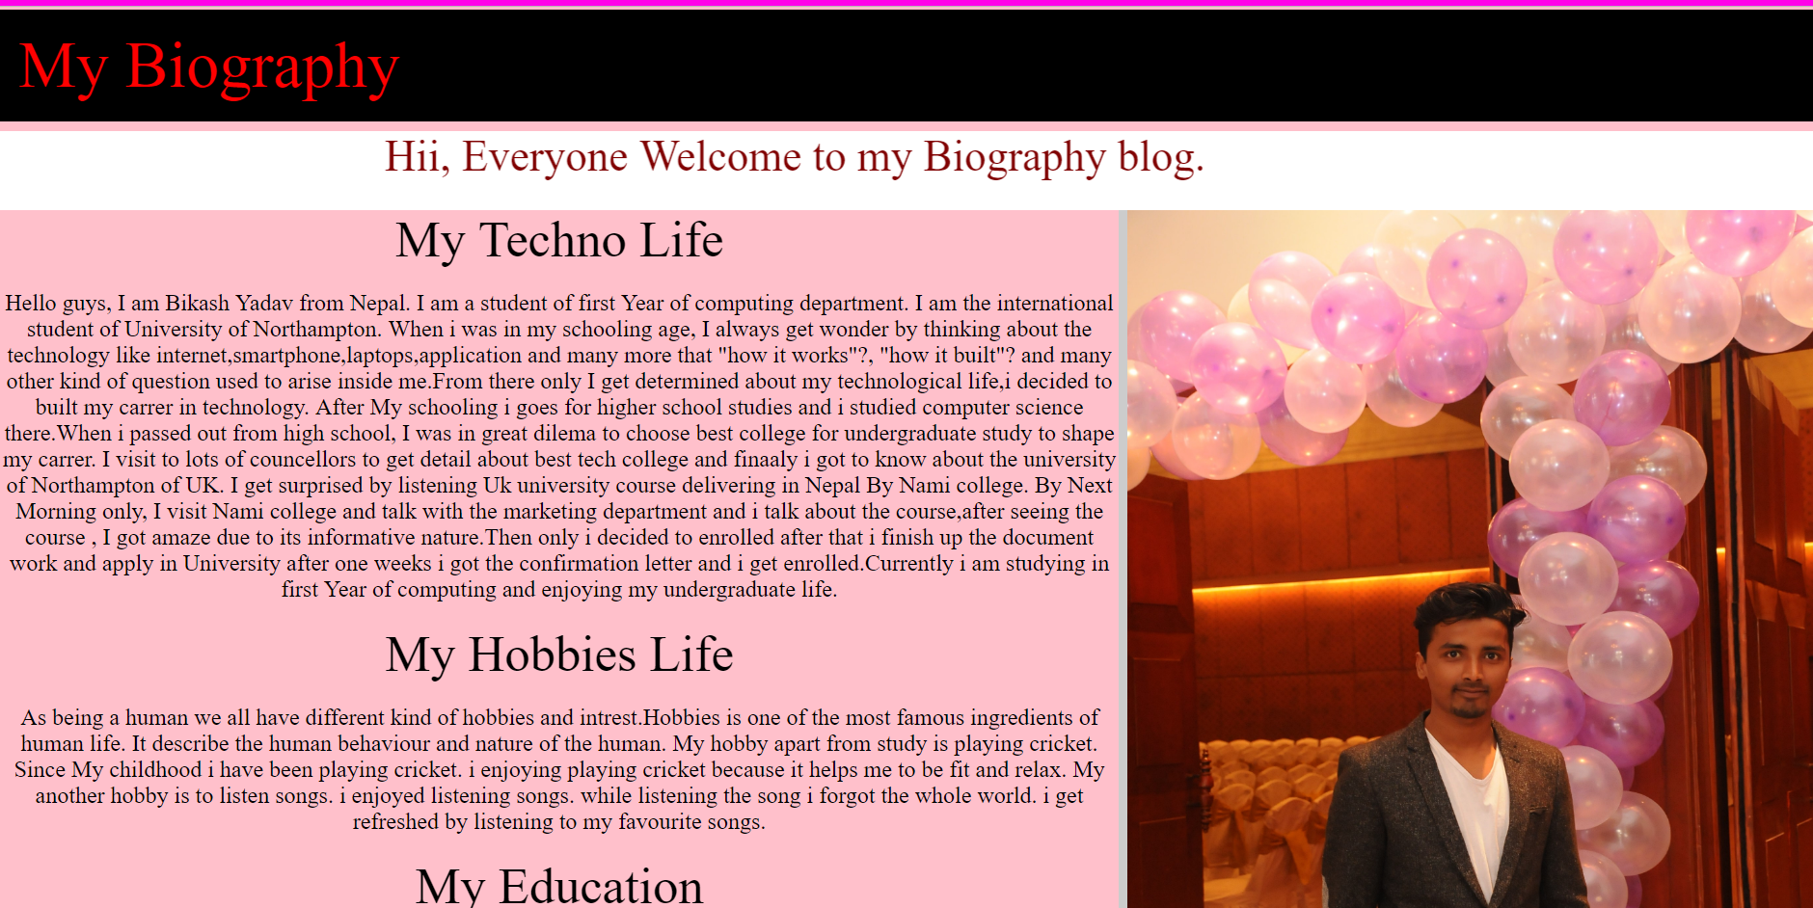

My Curriculum vitae page:

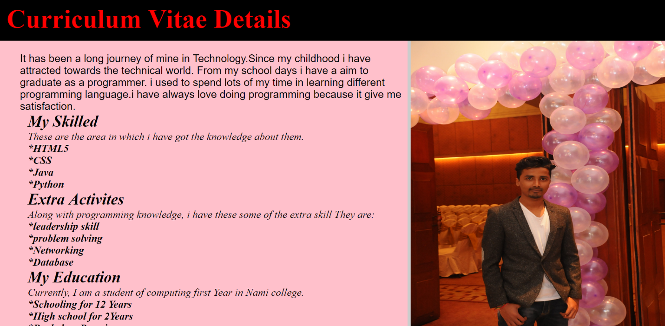

My contact page:

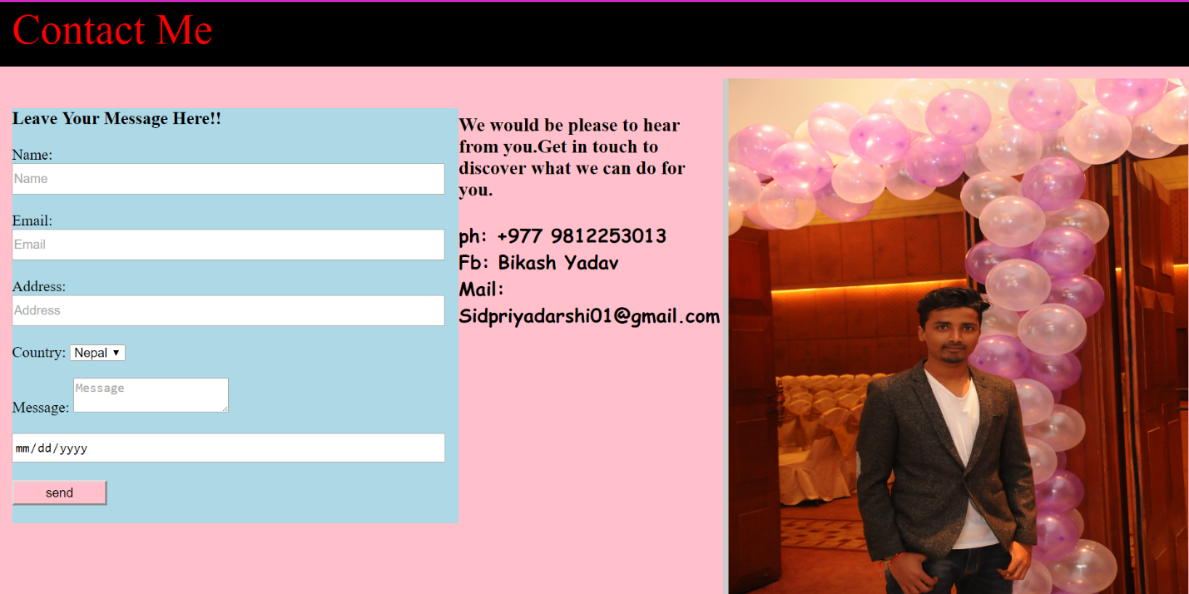

Conclusion:

Finally, we came to the conclusion. From the conclusion, I accomplished that during the development phase of this webpages, I was totally unknown about the web coding but slowly I get familiar with html and CSS coding. During the work, I look for better design but I have no idea, when I look my friends webpages I started think about instead of copying others webpage design why not I create my own design for better creativity. From there I started making my own design. I have completed my work totally different from others. I have used my own thought of color combination, font style and size and many other essential things of html and CSS. From this web project, I have also decided that in upcoming future I will be doing more in the webpage designing area because the interest or satisfaction I get from the html and CSS coding is unbelievable.

**Links to my github account :**

* My GitHub Links : <https://github.com/Bikashkr/csy1018b>

**References:**

* Stanford, J. (2017). *joel.sh - home of Joel Stanford*. [Online] joel.sh. Available at: https://joel.sh/about[Accessed 25 Mar. 2017].
* How to create CSS Layouts - Web Development Tutorial for Beginners (#3) - with HTML & CSS. (2013). [video] Available at:

https://www.youtube.com/watch?v=9tzyJEwO9Os&t=255s [Accessed 25 Mar. 2017].

* https://www.youtube.com/watch?v=5JbBOfYjMhs, (2012). *Intro to HTML and CSS part 22 - Social Media Links*. [Video].
* Mymoney.gov. (2017). *MyMoney.Gov - My Money Home*. [online] Available at: <https://www.mymoney.gov>[Accessed 30 Mar. 2017].